TEST DOCUMENT ON PROJECT X: SCANNING FEATURE

STUDENT SIDE:

Step 1: The student will Login his/her credentials

Step 2: Once Logged in it will direct to the Student Dashboard

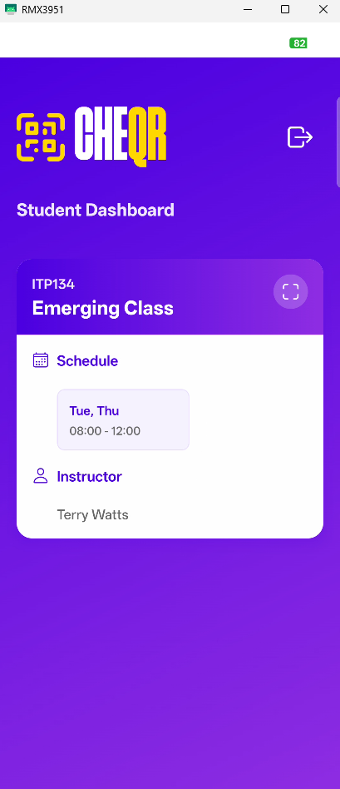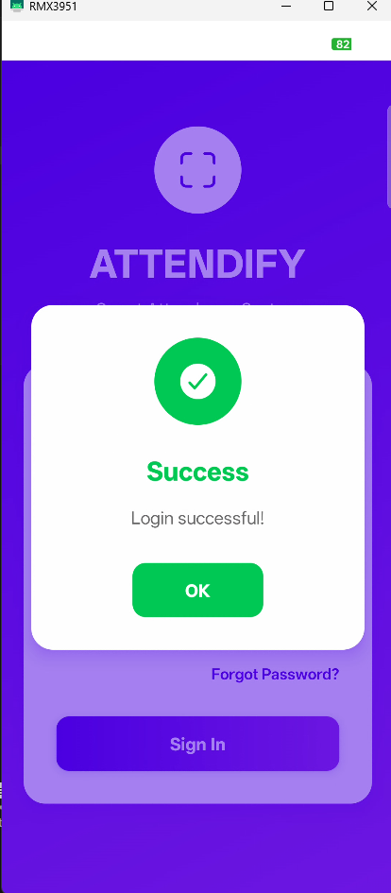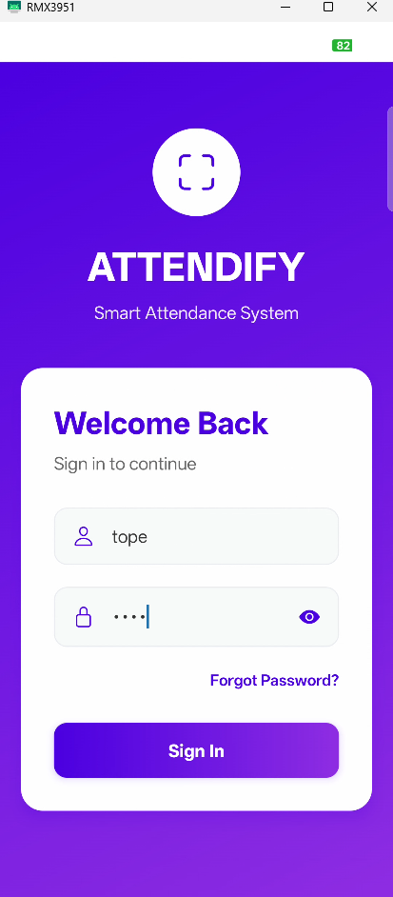

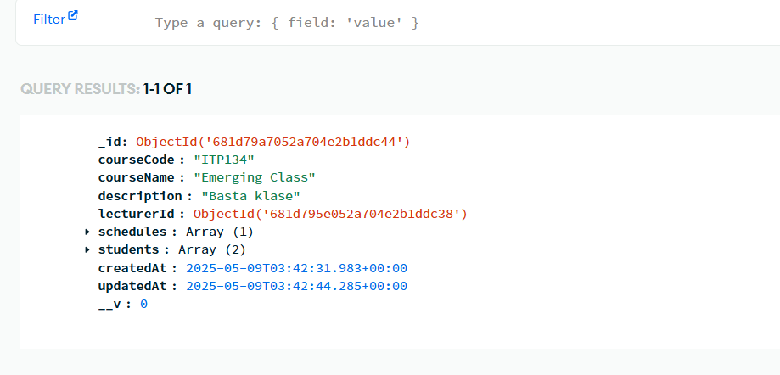Database: Course Query

LECTURER SIDE:

**Step 1:** The lecturer will Login his/her credentials

**Step 2:** After Logged in it will direct to the Lecturer Dashboard

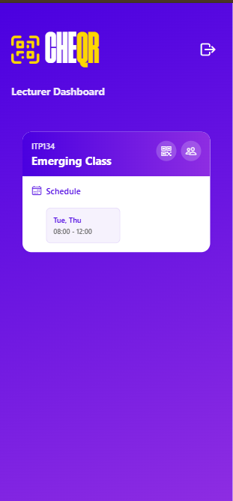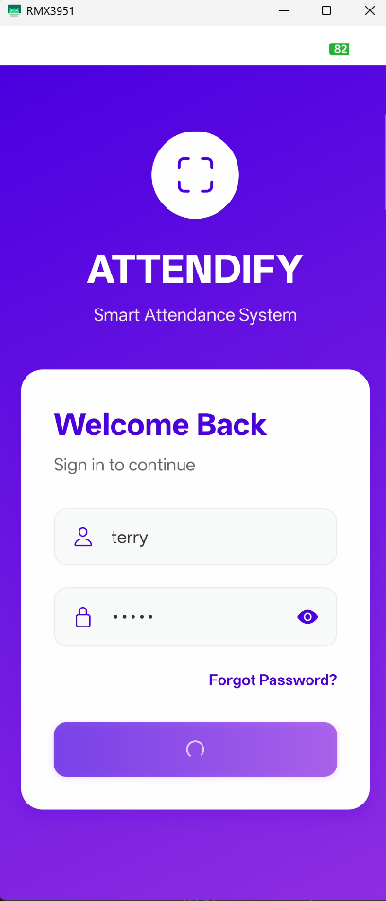

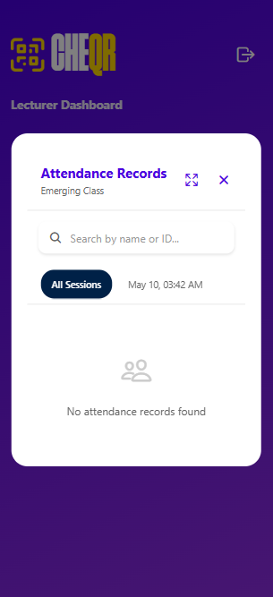**Step 3:** Once clicked the Generate QR button, it will show the Cours e QR Code Screen and the Attendance Records screen is empty first.

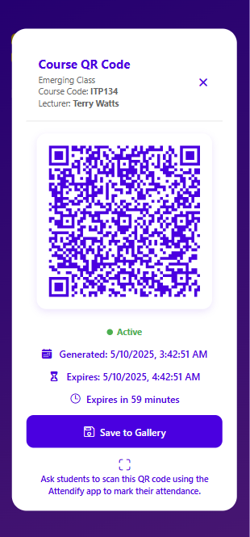

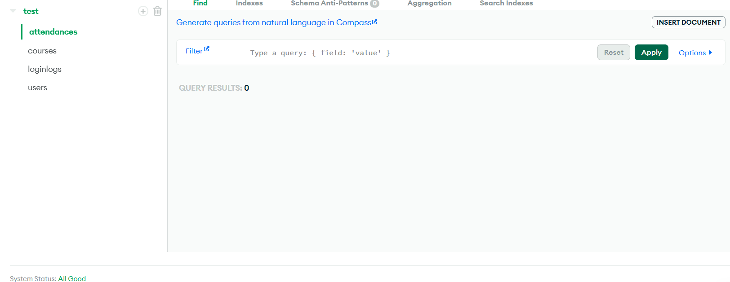

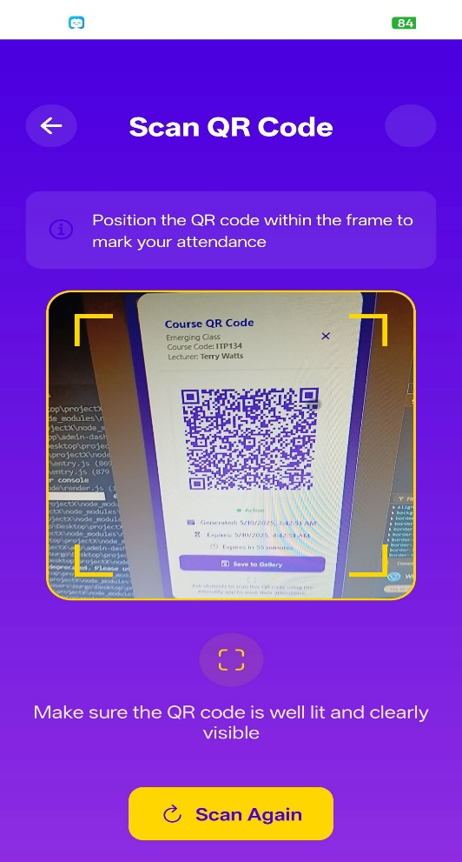**SCANNING FEATURE:**

Once the Lecturer generates a QR Code the Student will scan it

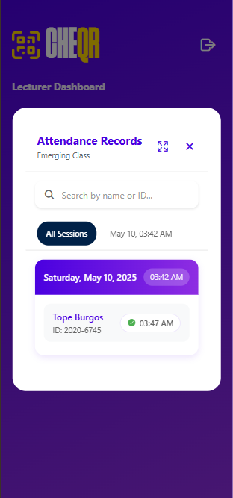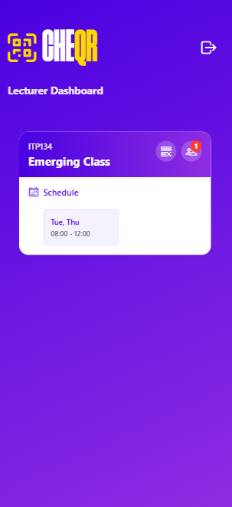The student will automatically recorded to the Attendance Records

Then the Datebase will add the student on the Array indicating he/she scanned the QR Code

